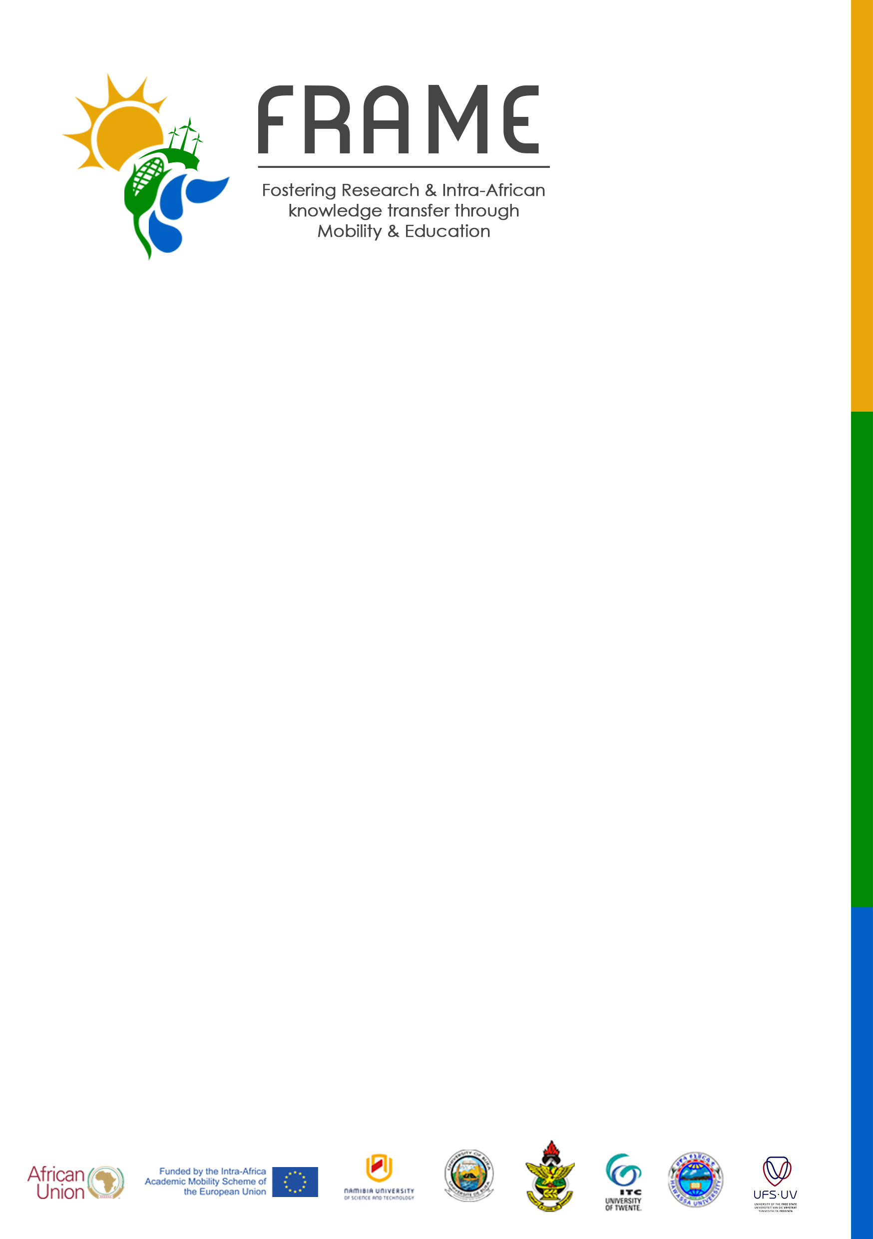
frame@nust.na
http://frame.nust.na
+264 61 207 2186

ARRIVAL NOTICE
Candidate’s last name: | Candidate’s first name:
FRAME ID number: | Candidate ID (home) if applicable:
Type of Mobility: | Target Group:
Home University: | Host University:
Arrival Date as shown on the boarding pass: (day/month/year) | Mobility Period:
Arrival Date at the Host University: (day/month/year) | Planned Return/Departure Date:  (day/month/year)
Address during the mobility at the Host University: | Email:

Candidate’s signature: Date:
Host University
We confirm that the candidate has arrived at our institution and a copy of the boarding pass is attached below.
Responsible person for FRAME at the Host Institution.
Name:
Signature:
Date:
Stamp/Seal of the institution:

****Please submit a photographic copy and original boarding pass. The original boarding pass plus a copy of the signed/stamped Arrival Notice must be mailed back to the FRAME coordinator in Windhoek within 30 days of your arrival at the Host Institution.

