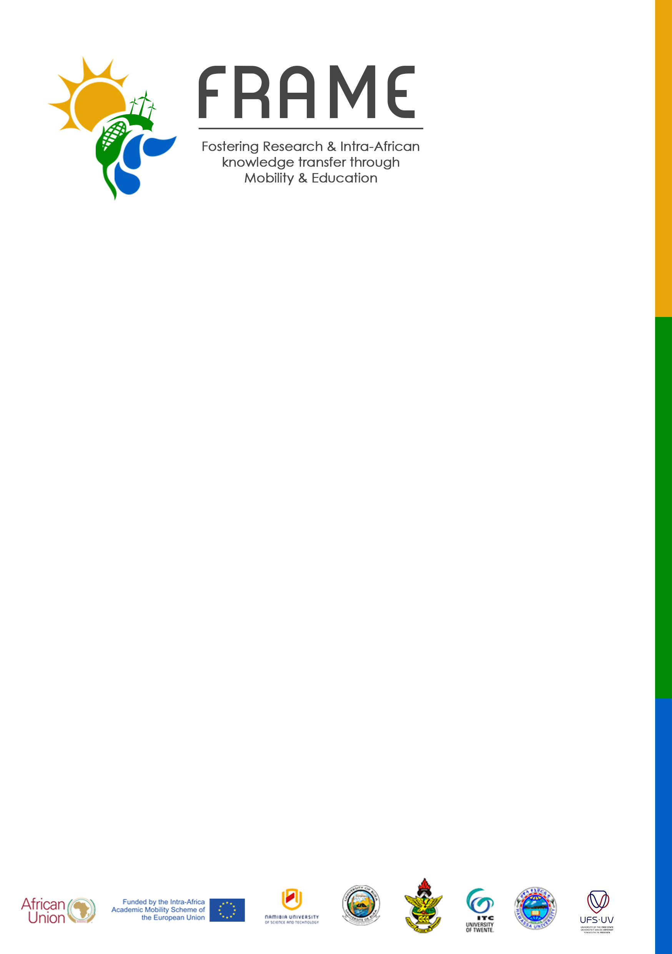
frame@nust.na
http://frame.nust.na
+264 61 207 2186

DEPARTURE NOTICE
Candidate’s last name: | Candidate’s first name:
FRAME ID number: | Candidate ID (home) if applicable:
Type of Mobility: | Target Group:
Home University: | Host University:
Date departure as shown on the boarding pass: (day/month/year) | Mobility Period:
Date of departure from the Host University:  (day/month/year) | Date of arrival at the Home country:  (day/month/year)
Email:

Candidate’s signature: Date :
Host University
We confirm the participation of this candidate under the Fostering Research and Intra-Africa Knowledge Transfer through Mobility and Education (FRAME) project during the period indicated above.

Responsible person for FRAME at the Host Institution.

Name :

Signature :

Date :

Stamp/seal of the institution:

****Please submit the photographic copy and original boarding pass of your ticket to the FRAME contact person within 5 days of the arrival date. The original boarding pass should be sent to the coordinator in Windhoek within 30 days from the date of arrival.

