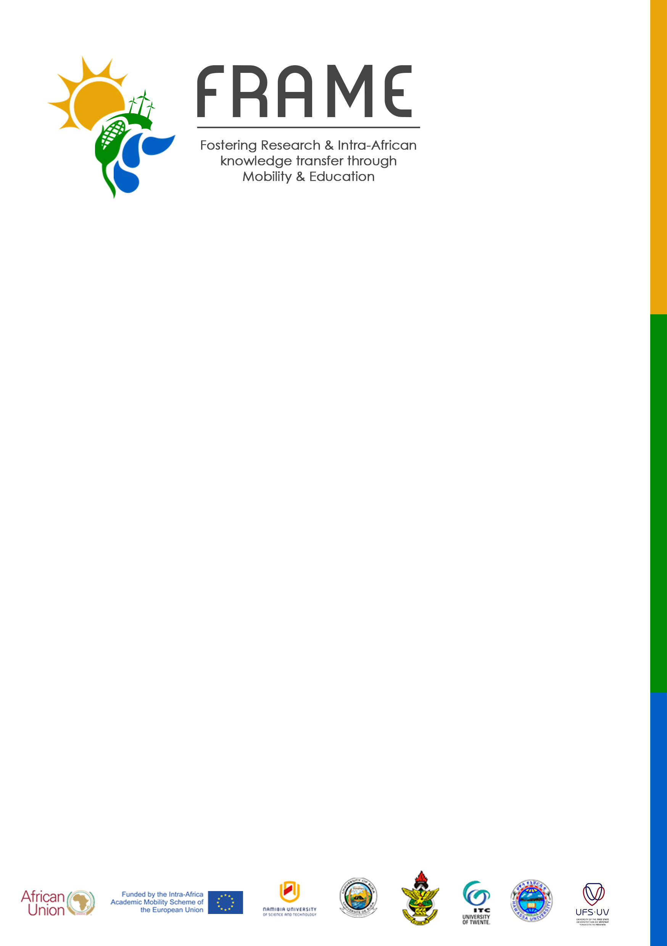
frame@nust.na
http://frame.nust.na
+264 61 207 2186

DEPARTURE NOTICE
Candidate’s last name: | Candidate’s first name:
FRAME ID number: | Candidate ID (home) if applicable:
Type of Mobility: | Target Group:
Home University: | Host University:
Expected Date of arrival at the Host University:  (day/month/year) | Mobility Period:
Date of departure from the Home University:  (day/month/year) | Arrival Date in the host country as per boarding pass: (day/month/year)
Email:

Candidate’s signature: Date :
Home University
We confirm the participation of this candidate under the Fostering Research and Intra-Africa Knowledge Transfer through Mobility and Education (FRAME) project during the period indicated above.

Responsible person for FRAME at the Home Institution.

Name :

Signature :

Date :

Stamp/seal of the institution:

****Please submit the original boarding pass of your ticket to the FRAME contact person within 15 days of the arrival date. This will in turn, be sent to the coordinator in Windhoek within 30 days from the date of submission.

